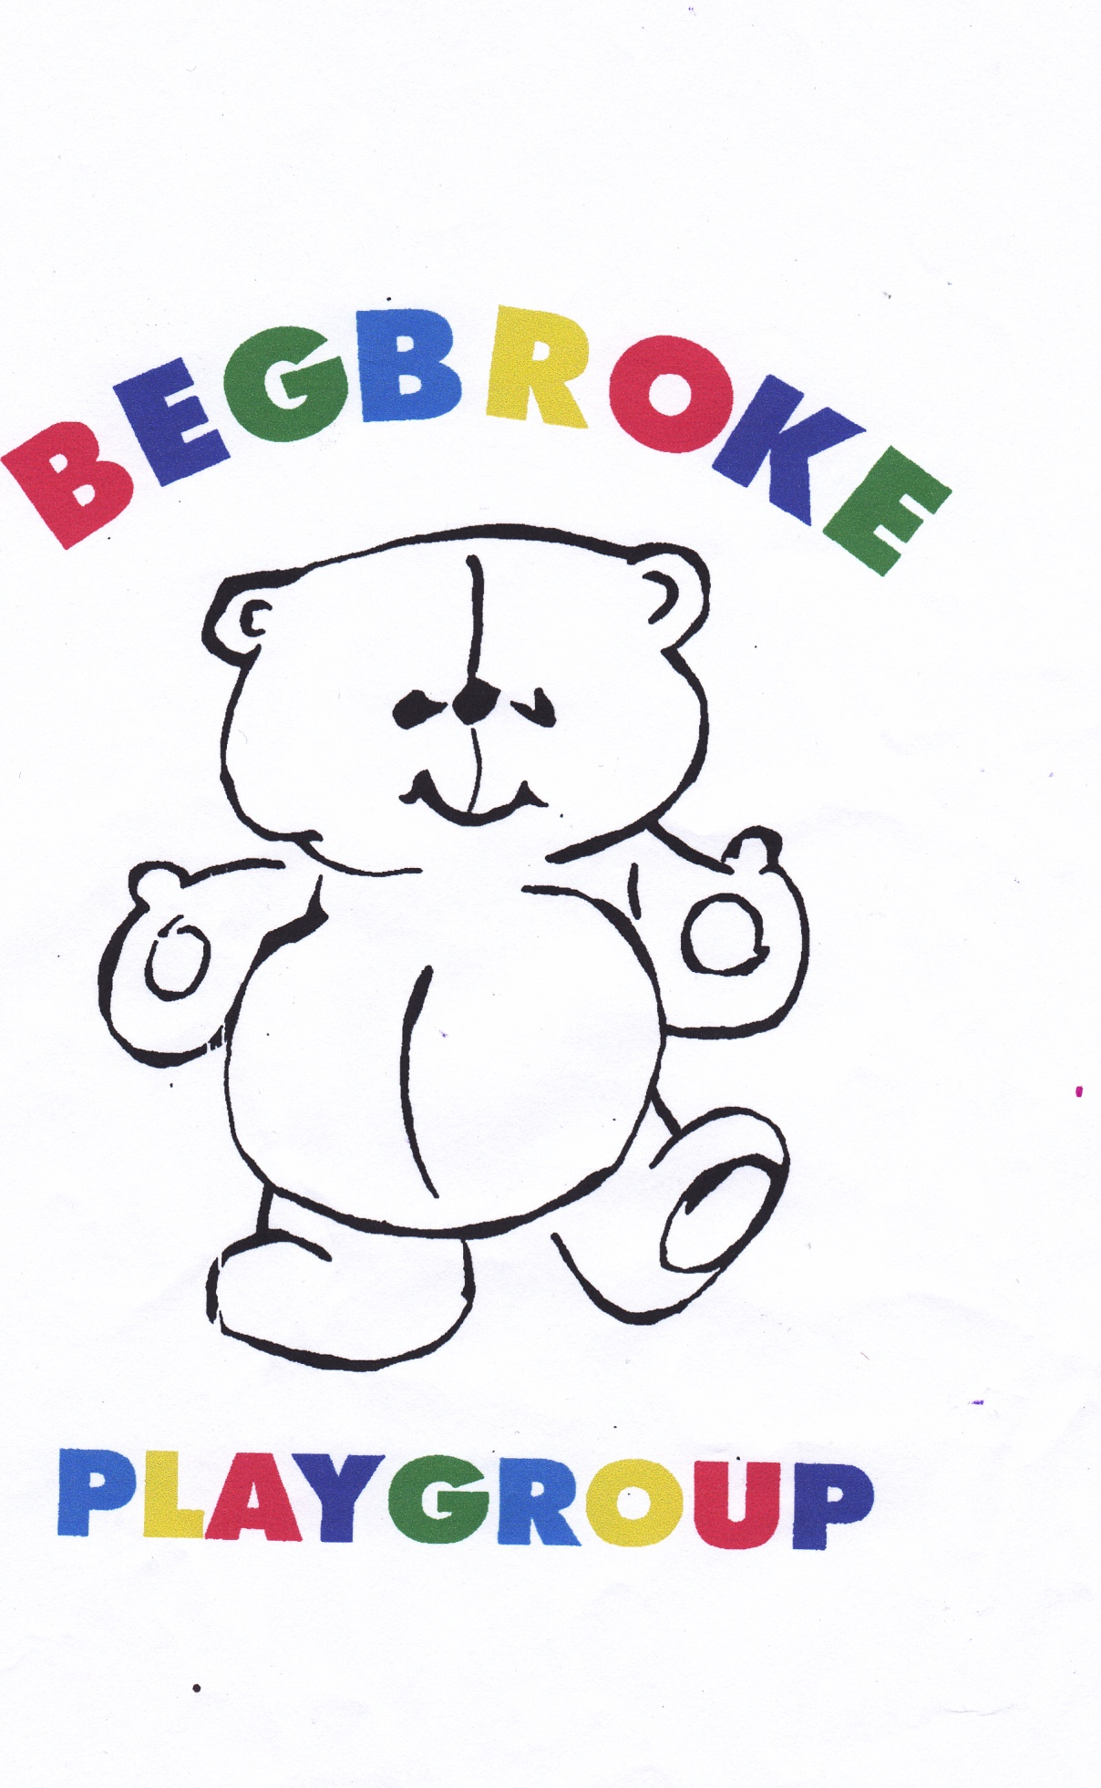

Begbroke Playgroup, Begbroke Lane, Begbroke OX5 1RN
karen@begbrokeplaygroup.org.uk
Phone: 07594 652291
http://begbrokeplaygroup.org.uk
Check out our Facebook page
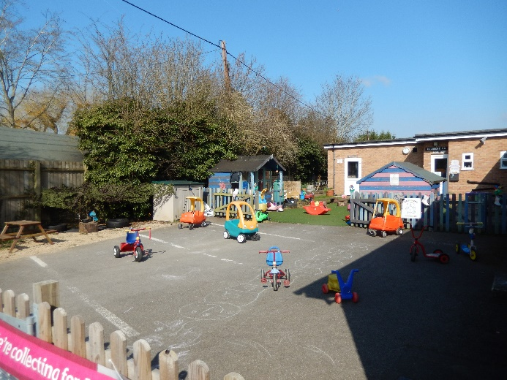

About Begbroke Playgroup

Begbroke Playgroup is about playing and is not a pre-school. We know that children learn naturally though play and support children to develop skill at their own pace within the framework of the Early Years Foundation Stage.
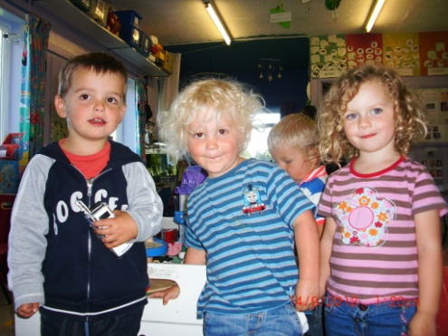
We are a small playgroup providing a smaller environment than many settings, but we feel this is an advantage, especially for children for whom this is their first time away from home. With three qualified staff with over forty year’s experience between them we provide a high level of care. Staff retention is very important to us as it provides consistent care for the children, which in turn allows the building of secure relationships between staff, children and parents providing an enabling environment for children to earn how to socialise with each other.

We believe socialisation and learning how to play together are the most important skills to learn, setting children up with a solid foundation carry them through their school life and beyond. With the ability to negotiate compromise and empathise with others, children will flourish throughout their lives.

We help develop self-confidence and independence in children, encouraging them to self-register in the morning, wash their hands when necessary and choose what they want to do with their day within the basic structure of the day.

Terms and Fees
Begbroke Playgroup is a term time only setting. We follow Oxfordshire county council term dates which we publish within the setting and on our website. Our opening hours are 9 am until 3 pm and we charge fees on an hourly basis. We accept children from 2 years until the term after their fifth birthday. We offer/accept two-year-old working parent funding, universal 3-year-old funding and 30 hours offer.
£5.50 – two-year olds
£5.00 – 3 and 4 year olds.
Our Staff
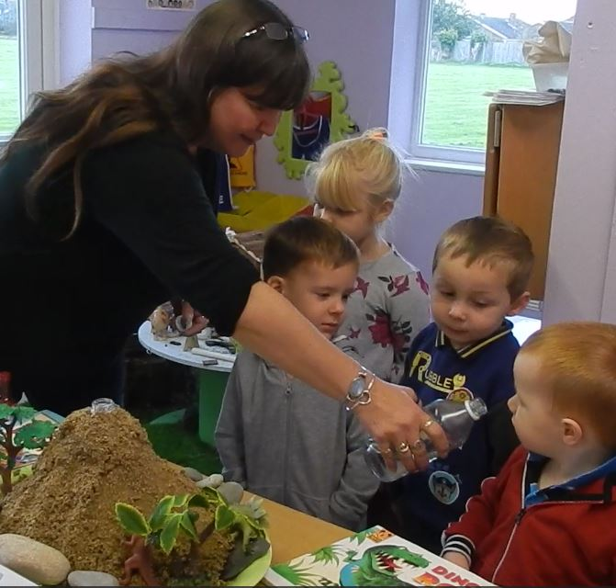
Karen Smale – Co-Manager- Level 3 qualified
Karen has been running Begbroke Playgroup for over 19 years, having three children herself she has a wealth of experience to help her support the children in their life at playgroup. Karen is the Special Educational Needs Co-ordinator and has overall running of playgroup.

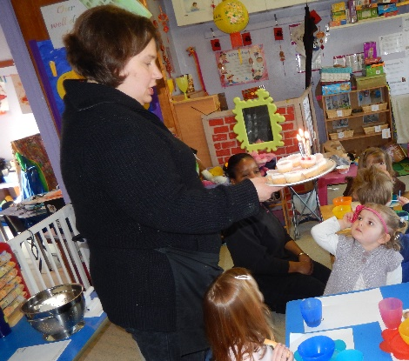
Caroline Waugh Co-Manager
Caroline has chaired our committee for a number of years and is working at playgroup having achieved the Level 3 qualification. Caroline brings a wealth of knowledge and academia to our group engaging the children in various learning activities. With her interest in the way children learn she brings understanding and care to our setting. Caroline is our designated safeguarding lead.
Hannah Yeatman
Born and bred in Begbroke, Hannah recently qualified with her level 3 qualification in childcare having volunteered in playgroup for several years while studying both at school and college. Hannah has been involved in Girlguiding for many years and is a young leader for the Woodstock Rainbows unit. Hannah is a regular performer and now director in the Oxfordshire Gang Show, treading the boards at Radley College every February,

Anna-Lise Love
Anna is also born and bred in Begbroke; she attended here as a child! Anna has a wealth of experience after 10 years of being a teaching assistant before having children. She joined the staff at playgroup in October 2023 and brings a great energy and can do attitude. Anna is starting studying for her level 3 qualification.

Our facilities
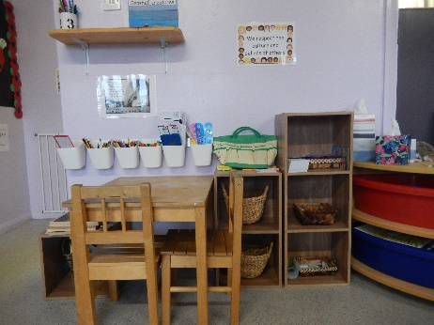
Begbroke Playgroup is based in an annexe Begbroke Village Hall; originally the cricket club changing rooms, we have carried out extensive work to produce a comfortable and stimulating environment for the children. We have a separate toileting area with child size toilets and wash basins. In addition to this we have an adult toilet and nappy changing facilities. We have a larger main room and smaller ‘messy room’ which are zoned to cover all seven areas of learning from the Early Years Foundation Stage Framework

- Writing area
- Block work zone
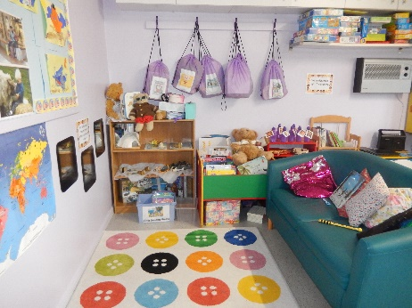
- Book room with low level seating
- Small world
- ‘Home corner’
- Art corner

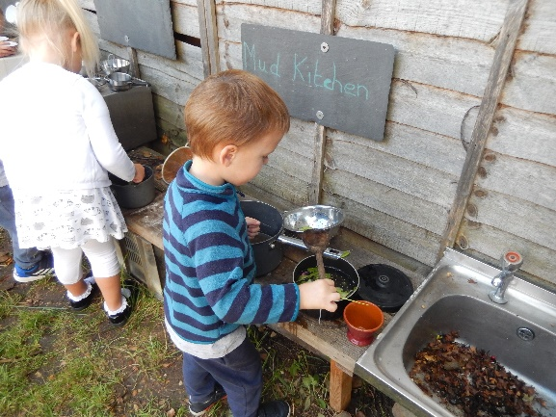
We have an outdoor area accessed directly from the playgroup building with an all-weather artificial grass surface, a grassed area, hard surface area and a sensory garden. There is a summerhouse and a children’s playhouse plus a climbing frame, mud kitchen and sandpit. We have a large number of scooters and bikes to ride on our hard surface area to give variety for different abilities in outdoor play.

Surrounding the village hall is a recreation ground and a children’s playground which is maintained by the village hall and parish council.
A typical day at Begbroke Playgroup
9.00 Parents and children arrive, children hang up their coats and bags, packed lunches are put in the fridge and children put their bear on the cupboard door as self registration.
Two or three focussed activities are on the tables to engage children. Home corner, painting, sand pit, small world, blocks and reading corner are always available.
If the weather is good the children can go outside to play if they want, focussed art activity if the weather is bad.
9.30 Group time – Phonics phase 1 activities and games
9.50 Free flow indoors and outdoors
10.20 Tidy-up time followed by singing/story time
10.30 Snack time
11.00 Free flow indoors and outdoors weather permitting.
11.45 Tidy-up time followed by story time.
12.00 Lunchtime
1.00 Free Play – child initiated
1.30 Adult led/child led activity/Free flow
2.40 Tidy up time.
2.45 Singing/story time.
3.00 Home time
Healthy Living
Begbroke Playgroup is committed to encouraging enthusiasm for healthy living. We supply a healthy snack every morning consisting of a selection of fruits, followed by two savoury items such as crackers or a piece of toast. We provide milk or water to drink. Children pass out cups themselves and pour their own drinks and select their own fruit. At snack time and lunch time all children wash their hands and sit on a small table of 3 or 4 with a member of staff.

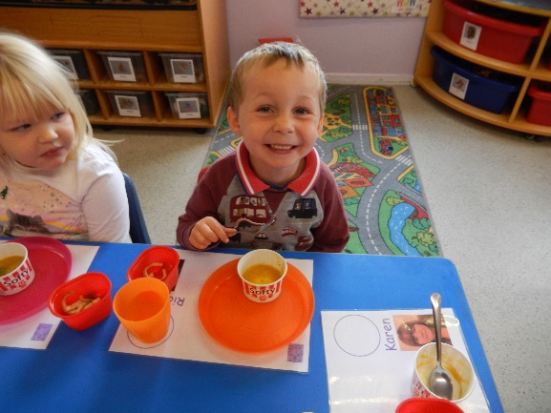
Children eat their sandwich/carbohydrate item first, then are asked to choose from the rest of their lunch. Once each child has finished eating, they wait five minutes to let their lunch go down. They are encouraged to read the time on the clock themselves to get down from the table.
Water is available at all times from individual photo and labelled drink bottles and children are encouraged to use them whenever they want.
We have at least one session of physical activity each day come rain or shine, this may be organised games outside or allowing the children to create their own fun, if the weather is bad we organise dancing or active games inside.
Snack is provided by playgroup and is included in the hourly rate. Lunch is provided by the parent/carer.

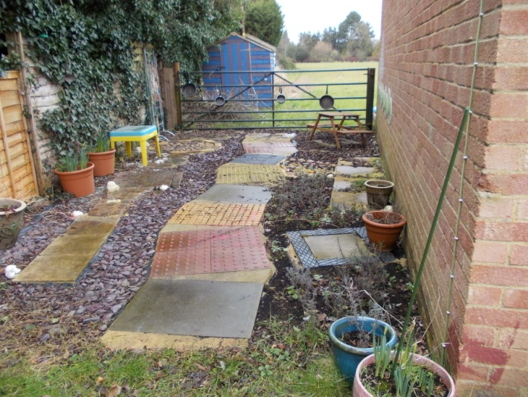
In partnership
We welcome parents into Begbroke Playgroup and encourage parental involvement in lots of ways.
We involve parents in the education of their child and ask them to help us with their child’s Learning Pathway which involves Photos and Pictures, Observations, Child Contribution, All about Me, 2-year Learning and Development and Child Profile. We share the Learning Pathway with the child also.
Our setting recognises parents as the first and most important educators of their children. All of our staff see themselves as partners with parents in providing care and education for their children. There are many ways in which parents take part in making our setting a welcoming and stimulating place for children and parents, such as:
- exchanging knowledge about their children's needs, activities, interests and progress with our staff;
- contributing to the progress check at age two;
- helping at sessions of the setting;
- sharing their own special interests with the children;
- helping to provide and look after the equipment and materials used in the children's play activities;
- being part of the management of the setting where appropriate;
- taking part in events and informal discussions about the activities and curriculum provided by the setting;
- joining in community activities, in which the setting takes part; and
- building friendships with other parents in the setting.

Transition
Begbroke Playgroup mainly feeds into Woodstock Primary School and William Fletcher School in Yarnton and we work closely with these schools to ensure a smooth transition for the children from playgroup to the foundation stage of school.
We also support children attending other settings part time to ensure a cohesive journey through their early years.
We are able to access support from Oxfordshire County Council and can make relevant referrals for children that we feel need additional support such as speech therapists and special educational needs advisors. We are members of the Early Years Alliance which allows us to access online training and legal support.

Key Person
Each child is assigned a key person, so you will have a familiar person to hand over your child to, especially in the early days. All our staff are fully briefed on each child and a ‘Buddy’ key person will be appointed if the regular key person is unavailable. We monitor the progress of each child is through observation of their play in different contexts. We use these observations to plan the “next steps” in children’s learning and development in ways that best fit their interests and learning style. You are welcome to speak to your child’s key person or the Manager at any time should you wish to discuss any particular points. Appointments can always be made for more in-depth or confidential discussions.
Learning opportunities for adults
As well as gaining childcare qualifications, our staff take part in further training to help them to keep up-to date with thinking about early years care and education. We also keep up to date with best practice, as a member of the Early Years Alliance, through Under 5 magazine and other publications produced by the Alliance.
The management of our setting
Begbroke Playgroup is a charity and as such is managed by a parent led committee and relies on parents to operate. The committee make up the registered person with Ofsted and are responsible for:
- managing our finances;
- employing and managing our staff;
- making sure that we have, and work to, policies that help us to provide a high-quality service; and
- making sure that we work in partnership with parents.
We welcome parent helpers to come into playgroup to get involved in our work and see what the children do in a day. We operate several fund-raisers throughout the year and invite friends and family to join us in these child orientated events.
The Annual General Meeting is open to the all parents of the children who attend our setting. It is our shared forum for looking back over the previous year's activities and shaping the coming year's plan.
Inclusion
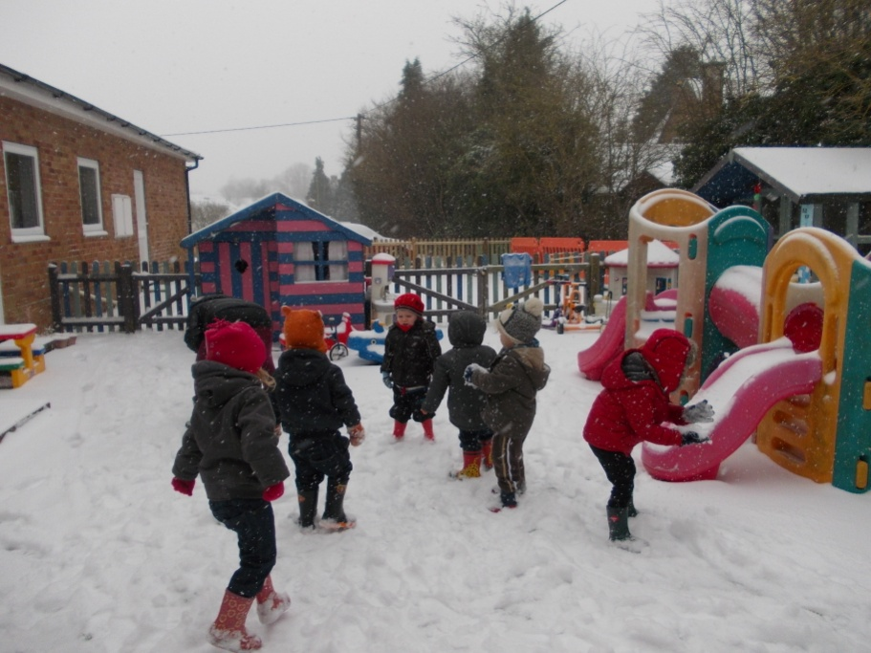
Begbroke Playgroup is committed to providing for children with special educational needs and developing cultures, policies and practices that are inclusive. We are also committed to supporting disabled children where possible, although we are constrained by the physical limits of the current building.

To make sure that our provision meets the needs of each individual child, we take account of any special needs a child may have. We work to the requirements of the Special Educational Needs and Disability Code of Practice: 0 to 25 years (2015).

Our Special Educational Needs Co-ordinator is | Caroline Waugh
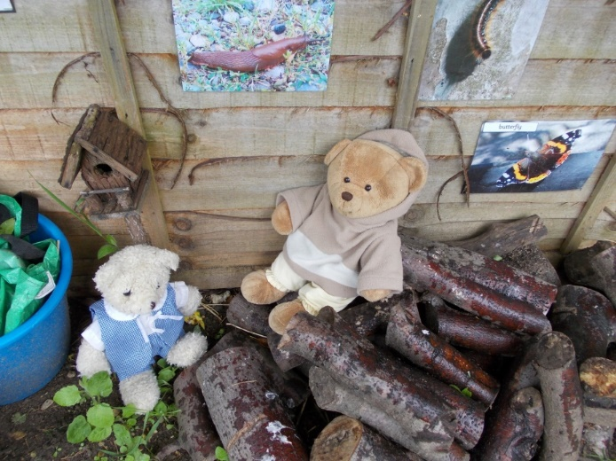

Safeguarding
Our setting has a duty under the law to help safeguard children against suspected or actual ‘significant harm’. Our employment practices ensure children against the likelihood of abuse in our setting and we have a procedure for managing complaints or allegations against a member of staff. Keeping children safe is everyone’s responsibility and at Begbroke Playgroup we have a particular responsibility to the children in our care. We work to ensure the children have a safe and stimulating environment within playgroup where they can develop themselves by having the opportunity to try new experiences, taking challenges and being supported by staff in an appropriate fashion. We intend to create an environment in which children are safe from abuse and any suspicion of abuse is promptly and appropriately responded to, all our policies are available to view at any time.
We have a duty of care to ensure that any significant concerns about the children in our care are reported to the local authority. We follow Oxfordshire Safeguarding Children’s Board guidelines and seek advice and guidance from Locality Community Support Service (LCSS) or refer directly to Multi Agency Safeguarding Hub (MASH)/Local Authority Designated Officer (LADO) as appropriate. We may consider any incident or observation of a child where we deem the child may have been or may be in the future at risk. In exceptional cases this may be done without prior knowledge of parent/guardian until we have sought external advice.

Policies
If you would like a hard copy of any of our policies, please ask a member of staff and they will supply them. We have also included our policies on our website at begbrokeplaygroup.org.uk

